Discrete uniform distribution:

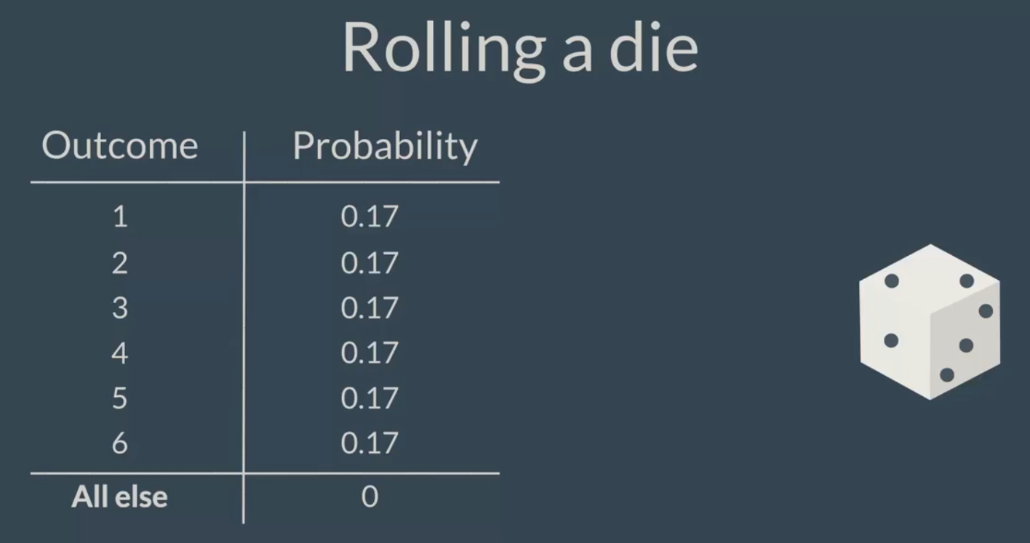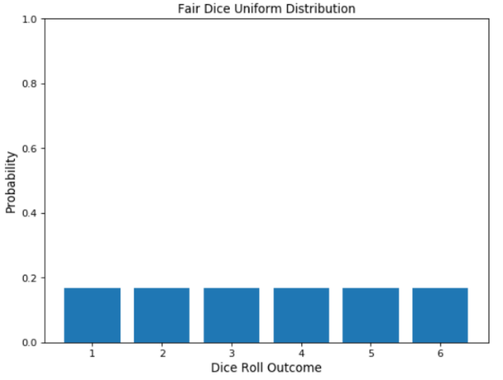

Binomial uniform distribution:

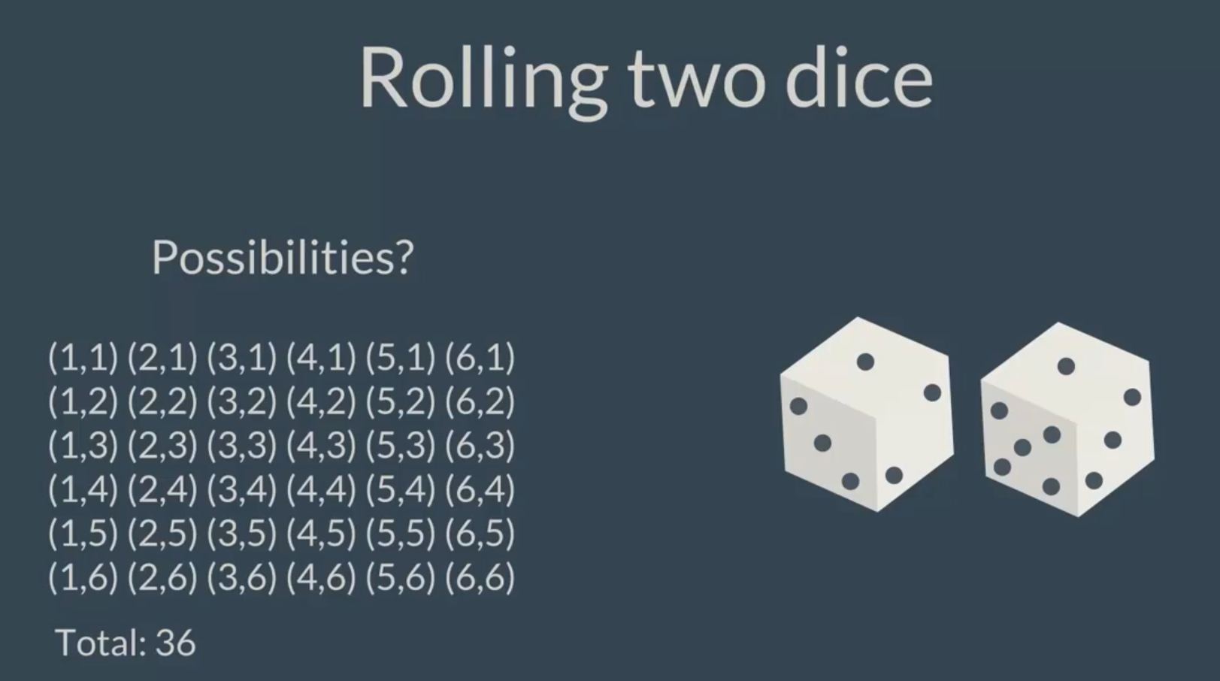 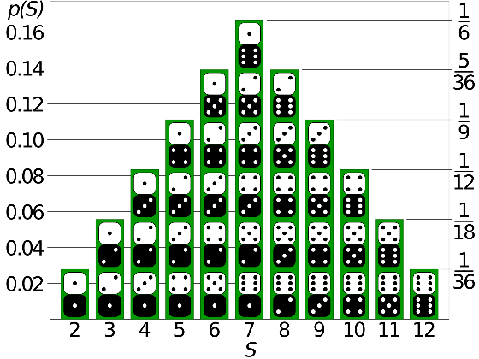

<https://homepage.divms.uiowa.edu/~mbognar/applets/bin.html>

Toss a fair coin 10 times and consider Heads to be a success:

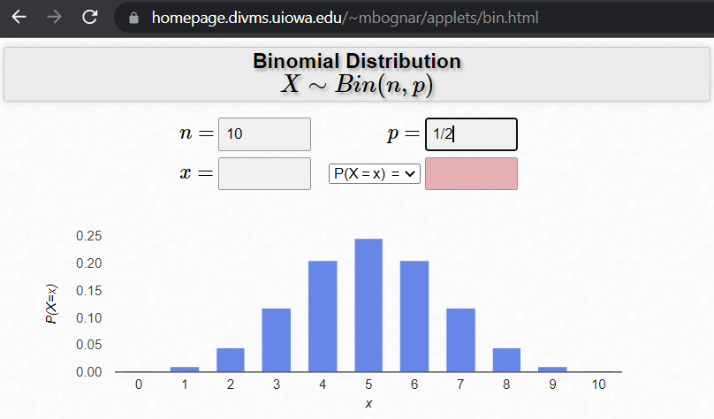

Toss a fair dice 10 times and consider 6 to be a success:

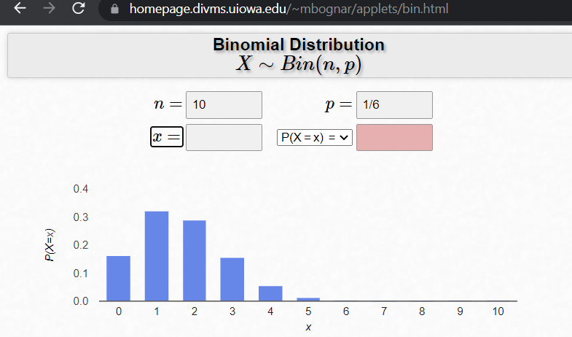

# Continuous Normal Distribution/ Bell curve:

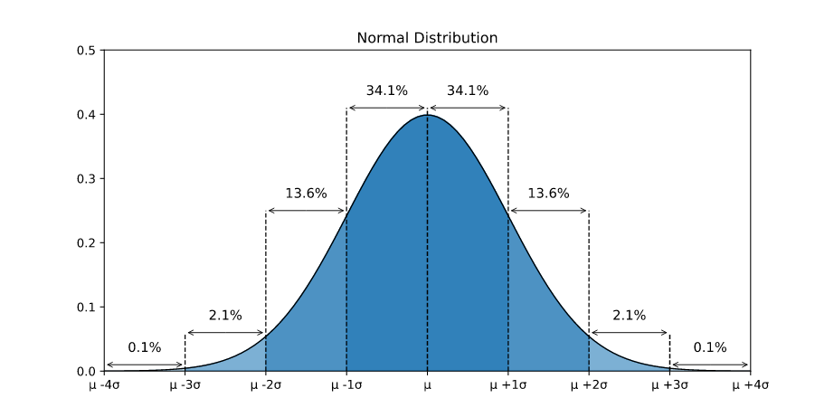

Example:

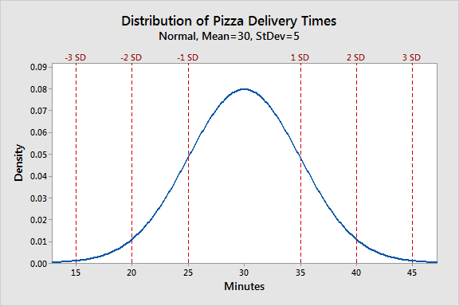

Extra: <https://www.youtube.com/watch?v=oI3hZJqXJuc&ab_channel=StatQuestwithJoshStarmer>

Marginal, Joint and Conditional Probability:

<https://towardsdatascience.com/marginal-joint-and-conditional-probabilities-explained-by-data-scientist-4225b28907a4>